April 5 Trading

Bull market crash probability: Tuesday>Thursday>Monday>Fri>Wed

Bear market crash probability: Monday>Thursday>Tue>Wed>Fri

Fri and Wednesday are the safest in terms of crash-resistance.

During bull market, Monday usually ends with a high percentile and when Tuesday opens higher, retAMCO has a negative expected return of 9 bps.

RetOPC<0 First chase time analysis:

Tuesday looks rather strong today.

Results from study of amMaxT1 and weekday:

**Monday:**

For big crashes, amMaxT is overwhelmingly in the first 6 minutes. **30/42 (71% Crashes have amMax before 9:36)**. Another 7/42 (16%) crashes have amMax before 10. Overall, that covers 88% of the crashes on Monday. Looking at the amMin, 19/42 (45% of the crashes have amMin after 11:24). 12/42 (28%) have their amMin after 11am. Overall 74% of all crashes have their amMin after 11am.



**Tuesday:**

Out of Tuesday crashes (30 crashes in total), 14/30 (47% have am max before 9:36). 7/30 (23%) crashes have am max before 10:00. That would make 70% of crashes have am max before 10am. 4/30 (13%) of crashes have am max between 10 and 10:30. 3/30 (10%) of crashes have am max before 10:30 and 11. 2/30 (7%) have am max between 11:18 onwards.

Ammin: Looking at the am min distribution, respective frequencies in each half hour: 6/5/5/14.

47% of crashes have am Min in the last half an hour (compare this with the 74% on Monday).

W



Wed:

22 crashes in total. **32% of crashes have am max before 9:36**. 6/22 (27% of am max occur between (9:36 and 10am). From 10 to 10:30, 4/22 (18%) of am max occur here. From 10:30 to 11, 23% of am max occur here. 1/22 (5%) of crashes have am max after 11.

On the am min front, **36% of min occur after 11:24**. 18% of min occur between 11am and 11:24pm. Overall, 55% of the am min occur after 11am. 5/22 (23%) occur between 9:30 and 10am. 2/22 (9%) occur between 10 and 10:30, 3 occur between 10:30 and 11am.



Thu:

On Thursday, 32 crashes were observed. 12/32 (37.5%) of crashes had am max before 9:36.

7/32 (22%) of crashes had am max between 9:36 and 10am 🡪 **59% of crashes had am max before 10am.**

6/32 (19%) of crashes had am max between between 10 and 10:30. The remaining 20% of am max was scattered in the rest of the am session.

In terms of the am min, 16/32 (50%) of crashes had am min after 11pm. 6/32 (19%) was between 10:30 and 11. (🡪 **70% of crashes had am min after 10:30**).

10/32 (31%) of the remaining crashes had their am min in the first hour.



Friday:

On Fridays, there were 21 crashes. **5/21 (24%) had am max before 9:36**. 6/21 (29%) had am max between 9:36 and 10. Overall 52% of am max appeared before 9:54. 29% of crashes had am max between 10 and 10:30. 14% crashes had their am max in the last hour.

For am min, **52% of crashes had am min after 11:18**. 43% of crashes had am min uniformly between 10:12 – 11: 06.



Wednesday, April 06, 2016

Market sentiment is weak. Therefore I do not want to use big positioning. Yesterday the US had a bad session and Europe bled. It is wise to wait until sentiment calms down a bit.

The below model has a ROC of more than 90%. This shows that the last 15 minute of the morning session as well as the beginning 10 minutes of the PM session is highly predictive of the crashes.

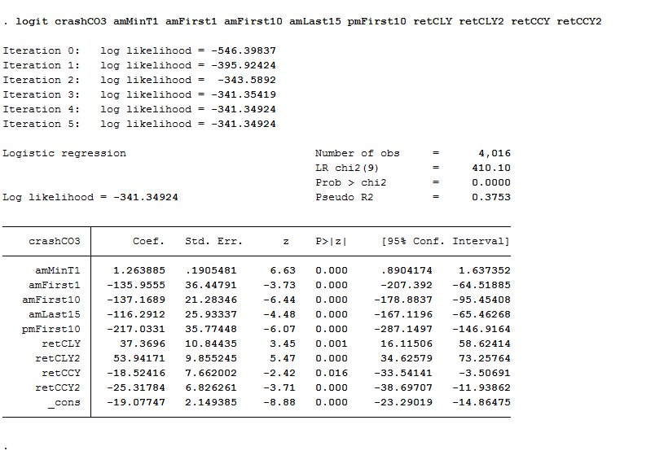

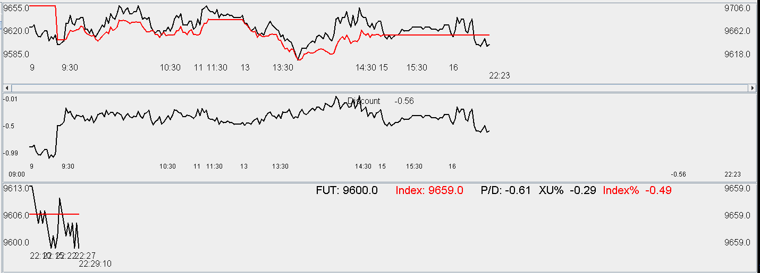

Going into the Thursday, markets remain weak. Wednesday was a weak session with no expected rebound. Currently the future is at a 61 bps discount. Tomorrow if the index opens low and heads lower in the first minute, liquidate position immediately.

Apr 7

Market opened up today. The first minute we saw a rally up. The expected retCL is about 1% and a position is cued at 9640.

Simple analysis yield

. count if weekday == 4 & retCO<-0.03

27

. count if weekday == 4 & retCO<-0.03 & retOPC>0

10

. count if weekday == 4 & retCO<-0.03 & retOPC>0 & amFirst1>0

3

With a high open and a first minute which was rushing up, the chance of a crash is small, therefore there will be a little positioning build-up today in anticipation of tomorrow.

Market is very resilient at this time refusing to drop first. Picked up some position @ 9640.

Cuing for another lot @ 9600. Got the position.

No more position will be added today. Market cleansing continues and position building has been complete at this point.

Thursday is very weak as usual. There is no sign of rebound. Decisions will be made on whether to cut position after 1:10pm.

Discount on A50F goes to -0.4% and breaks previous lows. Sentiment is bearish and investors are scared today.

Check back at 1:10 to see if position needs to be liquidated.

research results today:

First ten minutes of the PM session is crucial to the retPMCO.

Thursday is way too weak to play rebound. The buys were problematic.

Trading had no clue of the important of amFirst1, amFirst5 and amFirst10. More research will be done in these areas.

Today is a day when lack of knowledge takes its tolls on the account.

The trading style is influenced by Larry, which is sub-optimal. The morning buys were mostly too early.

Issues today:

1. Did not take into account the amFirst10 in trading
2. Downplayed the importance of today being Thursday where retCL is the weakest among the 5 days
3. Overemphasized the role of retOPC.
4. Morning buy times did not take into account the expected return. (All morning buys if amMin>9:45 is a losing trade held until 11:30)
5. Focusing on the retOPC and amFirst1 induced complacency and resulted in bad buying decisions.
6. No amMinT1 distribution was computed during the day, which was a testament to that complacency.
7. Self-scoring today: 0/5.

Going forward:

Take into consideration amFirst1, amFirst5, amFirst10.

Now, we need to integrate all the features and use a model to help us make decisions.

Methodology is weak.

Variables to take into account:

weekday, retOPC, amFirst1, amFirst5, amFirst10, amMin, amMax, amLast5, amLast10, amLast15,

Based on weekday and morning max times, amMin distribution is vastly different.

Define the term force as the latent variable in charge of generating the return to the close.

Power attempts to model the expected return to close by mining historically similar occurrences. KNN might need to be used.

**Better entrance decisions need to be researched. Right now it is completely random which is atrocious.**

What is the required is a solution to the following problem:

f(amMaxT amMinT, retOPC, amFirst1, amFirst5, amFirst10, retCLY, weekday, retCLY2, retCOY, retCOY2, retCCY, retCCY2) 🡪 g(possible buying times, E(retAMCL), E(retPMCO))

Any more multi-day variables? Multi-day percentile,

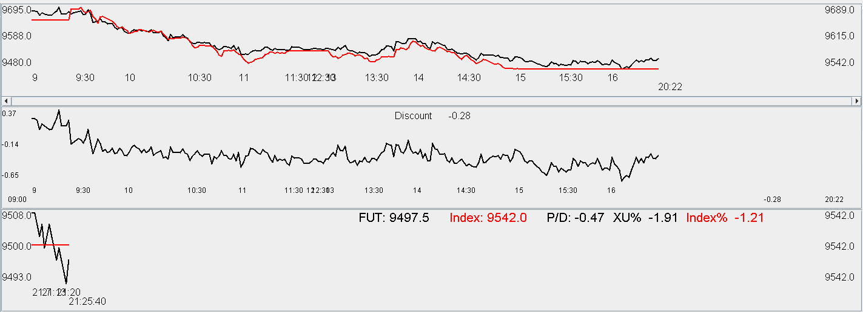

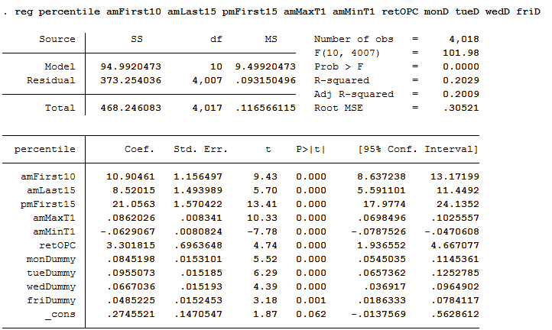

From the above regression, from the order of importance which determine the ending percentile:

pmFirst15/amMaxT/amFirst10/amMinT/amLast15.

Let's look at this one below:

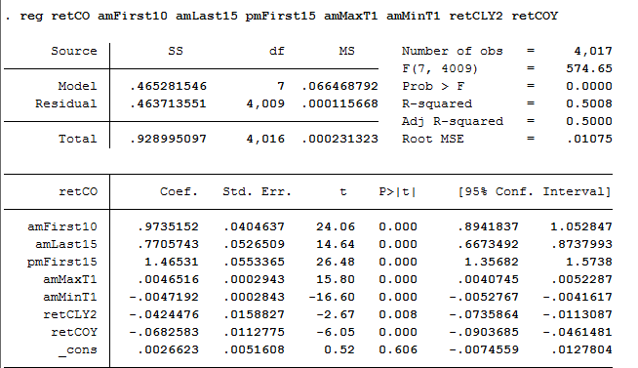

The above regression has 0.5 R2 which is not bad. It is interesting to note that yesterday's CO and the CL(T-2) reduce today's CO. Gaining an hour of amMaxT results in an increase of 47 bps, while gaining of an hour in amMinT results in the loss of 47 bps.

PmFirst15 exerts 1.5 times its gain/loss in the CO. (The effect is very strong)

AmFirst10 exerts an 1-for-1 gain/loss on the CO. (Strong effect, but not as much as PmFirst15)

Amlast15 exerts 80% gain/loss on the CO. (Still strong, not as strong as the first two).

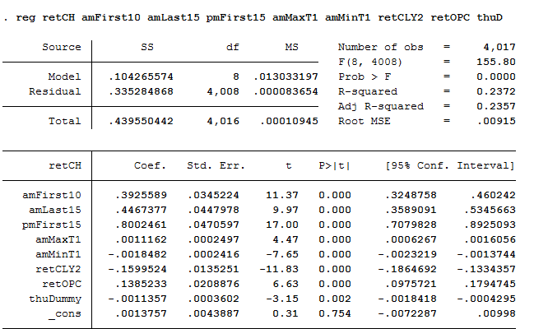

From the above analysis of retCH (the drawdown from high to close, a negative figure), pmFirst15 is the most significant factor, exerting 80% energy on the retCH. RetCLY(T-2) is the second significant factor, this means low to close return on T-2 will impact CH negatively (1% of retCLY2 will exert -16bps force on retCH).

AmMinT hurts more than amMaxT helps here. An hour of AmMinT hurts retCH by 18 bps but an hour of amMaxT only helps by 11 bps.

RetOPC is useful for once, an OPC provides an anchoring effect with 14% effectiveness. An retOPC of less than -2% directly reduces retCH by -30bps.

In short, position sizing needs to depend on AmFirst10 and retOPC.

Today's error was the overemphasis on the first minute return and retOPC instead of the fact that it is Thursday, the amMinT keeps deteriorating with the amMaxT stuck at 9:31. Bought 2 units this day was a result of incomplete thinking born out of complacency, which resulted in a sizable loss. Going forward, rules need to be developed on the buying points in the morning.

No big position when amMaxT is before 9:40 OR amFirst10 < 0. As soon as amMin occurs after 9:42, daily max already has a 60/40 (am/pm) distribution, dayMinT has 44/56 (am/pm) distribution.

**April 8, 2016**

The position is bleeding heavily. Holding an overnight position is hurting. Yesterday's trading mistake is having some negative externalities.

Keep in mind going forward to keep overnight exposure to a bare minimum. 3 lots on a Friday is acceptable, but it is important to follow probabilities, if the market opens low and heads down immediately cut position at 9:40.

Do not increase position now. If the market is clearly in correctional mode and there is no telling when the correction will be over.

**Stick to a maximum position of 3 lots because yesterday it was clear that you don't know what you are doing.** The new methodologies caused you to let down your defense and become euphoric and both the purchase decisions are wrong. Position should have been sold at the open and the situation should have more thoroughly analyzed. The weak amFirst10 was disregarded and the fact that amMinT1 was breaking lows well after 10am did not ring an alarm bell, which was dangerous.

Develop a prediction model based on the regression results as of yesterday.

**There are some basic insights which should be reviewed**

The unconditional distribution of amMin is 37/18/16/30(55/45) in the four half hours. As soon as amMinT happens after 9.6. The probability space drastically switches to 23/22/19/36 (45/55). This means when the market low occurs after 9.6, the better idea is to short instead of long, or the entrance point should be delayed to after 10:30 to ensure you can enter at AM min.

If amMin breaks 9.7 (9:42), the amMin distribution becomes 15/24/21/40 (39/61), this means you should wait until 11:00 to buy. Previously the buying times were random and displayed a distinct lack of discretion. This was the result of following Larry's methodology, which constitutes universal buying in the AM, resulting in big losses during crash scenarios, which he alleviates by holding universally small delta.

Your advantage over A share stock operators is that I can liquidate anytime, limiting the loss on a single day. I can reverse direction any given time. These choices are invaluable but also present challenges in using them properly. For the first quarter of this year, methodology had been emulating that of Larry, buying in the morning, wishing for a rise in the afternoon. This generated profits. However, position sizing was poor and the crash on Feb 24 (CNXT -10%) and Apr 7, (portfolio down -5k) was not prevented. These both exhibited weak amFirst10 on Thursdays. The usage of amFirst10 to determine strength is very important and this leads to position sizing differentiation.

Get ready to liquidate based on the first 10 minutes.

Some results on the conditional retCO/amFirst10

Cut all three positions @ 9440. Friday opened low and the first ten minutes showed weakness and there is nothing to do today. Market is rebounding but sticking to the methodology is more important. Yesterday max position was put on at random moments on Thursday, this was not acceptable which resulted in loss. Today reflect on that loss and do not trade.

|  |  |  |  |  |  |  |  |  |
| --- | --- | --- | --- | --- | --- | --- | --- | --- |
|  | amFirst10<0 |  |  | amFirst10 | retCO |  |  |  |
| Weekday | amFirst10 | retCO |  | P50 | P50 |  | Mean diff | Median diff |
| 1 | -0.36% | -0.50% |  | -0.25% | -0.30% |  | -0.14% | -0.05% |
| 2 | -0.30% | -0.35% |  | -0.21% | -0.21% |  | -0.05% | 0.00% |
| 3 | -0.25% | -0.27% |  | -0.20% | -0.22% |  | -0.02% | -0.02% |
| 4 | -0.29% | -0.40% |  | -0.21% | -0.39% |  | **-0.11%** | **-0.18%** |
| 5 | -0.24% | -0.36% |  | -0.16% | -0.27% |  | -0.12% | -0.11% |

From the table it shows that when amFirst10<0, it is best to short on Thursday, followed by Friday. Shorting on Thursday and Wednesday yields no benefits.

Let's examine the same table with the added condition that retOPC<0.

|  |  |  |  |  |  |  |  |  |
| --- | --- | --- | --- | --- | --- | --- | --- | --- |
| RetOPC<0 | Mean |  |  | Median |  |  |  |  |
| Weekday | amFirst10 | retCO |  | amFirst10 | retCO |  | Mean diff | Median diff |
| 1 | -0.38% | -0.67% |  | -0.29% | -0.56% |  | -0.29% | -0.27% |
| 2 | -0.34% | -0.34% |  | -0.23% | -0.31% |  | 0.00% | -0.08% |
| 3 | -0.24% | -0.32% |  | -0.18% | -0.26% |  | -0.09% | -0.07% |
| 4 | -0.31% | -0.41% |  | -0.22% | -0.39% |  | -0.10% | -0.17% |
| 5 | -0.24% | -0.35% |  | -0.16% | -0.22% |  | -0.11% | -0.06% |

From this table, it can be seen that Monday and Thursday are shortable given a retOPC<0 a weak amFirst10. Any other day is not shortable.

Note that from yesterday's model, Tuesday had a huge CL which exerted negative impact on the market on Thursday. The morning max distribution was extremely adverse on Thursday and positions piled up, it was not acceptable.

This week was about the worst week this year. Monday was holiday, Tuesday and Wednesday I did not trade. Thursday I bought two lots on the way down and Friday I cut all the losses. Very little capability was displayed and the performance was terrifying. Tuesday opened down but had a decent amFirst10.

Markets rally at the beginning of the PM session and pmFirst10 is significant. This is quite significant (more so than the amFirst10), however it is unlikely that this will continue (due to the AM computation, due to amMinT1 and amMaxT1.

Futures are tracking cash closely at -0.1% discount, investors are bullish on a Friday afternoon.

The afternoon bullishness is hurt by today's low retOPC, amMinT after 11, amMaxT around 10, and negative amFirst10, helped by pmFirst15. There are not too many reasons to hold until PM close (if had position), as the better idea would have been selling all the position during the afternoon euphoria in the early PM.

It seems that markets are reluctant to sell at this level.

After the cash close, future went to a 24 bps premium and achieved daily high. The rally towards the close was a result of the strong pmFirst15, which significantly helped with the percentile. The early afternoon weakness was from the retOPC and amFirst5. Today we see conflicting battles among various important determinants.

The liquidation point today was a little bit early. It was done at 9:36 following a day that closed at the lows. There were a few opportunities to sell today. Since today was not Thursday, selling in the morning was not recommended.

Unless it is a crash, markets will offer opportunities to sell. Today's selling decision (apart from its disciplinary purpose) could have been delayed a bit and three lots to be scattered. Heavy long position on a Thursday coupled with heavy losses made the situation very inflexible.

It is important to reflect on these mistakes.

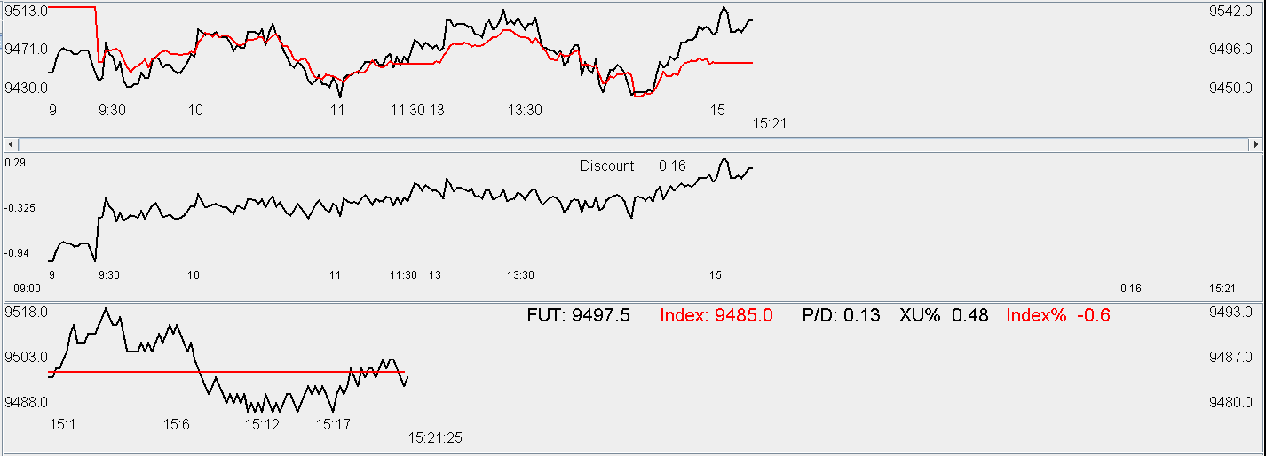

Weekly review:

It was far from a pleasant week. Heavy losses were suffered on Thursday as a result of an imprudent entrance.

Tuesday had a positive amFirst1 amFirst5 and amFirst10. It was OK to trade on this day. However, no trade was done because of lack of understanding of the features.

Wednesday, first1 was down, first5 was up, first10 was up. This basically eliminated crash scenarios. AmLast10 was up but pmFirst10 was down. It was a rather tasteless session.

Thursday, market opened high and rallied for a few minutes before ending negative for amFirst10. The drop did not stop and the amMaxT/amMinT and Tuesday's CL took heavy toll on the retCH, and the index was closed at the lowest. Maximum positioning was used on Thursday and entrance point picked was poor. The entrance needs to be after 11:00 to have a chance of retPMHAML. PmFirst15 was good and it led to a small rally in the middle of the PM session, before it was pulled down by amMinT and amMax and Thursday dummy.

Friday, the price action was range-bound, the session opened low and amFirst10<0. PmFirst10 was good and this resulted in a rally. Weak amFirst10 and retOPC pulled it down to a low near 14:30, then pmFirst10 helped it back up.

Futures is currently trading at 0.24 premium as operators are looking forward to next Monday and the US recovery on Friday. However, it will depend on Monday's retOPC and amFirst10 which will depend on the US price action tonight.

This week exposed the fact that the operator is still inexperienced and important features in the market are being missed and there are a lot of operating mistakes. Lack of action on Tuesday, and over-action on Thursday and lack of discretion regarding entrance points on Thursday were testament to this lack of knowledge and experience.

Going forward, it is important to keep mining for the factors that are important and relevant. This week, the research has advanced well, where regressions results were statistically significant. However, care must be exercised when applying the results. The selling decision of this morning was equivalent with shorting which must be done at the highs unless it is Thursday or Monday under certain conditions. Today's selling point was considered panic which was very weak. Therefore, this week's trades have all been trading mistakes which are to be avoided in the future.

